CMPS310 project
Pearl Mart Inventory Management System
Milestone 2
Fall2026 - L52
Group 4
Student name | QUID | Effort%
Shimaa Mohamed | 202212290 | 33.3%
Shaima Al-Sayadi | 202204874 | 33.3%
Shouq Al-Mannai | 202402316 | 33.3%

Task1 – Object Interaction and Focused Class Design:
- sequence diagrams for UC04 – Add Goods:
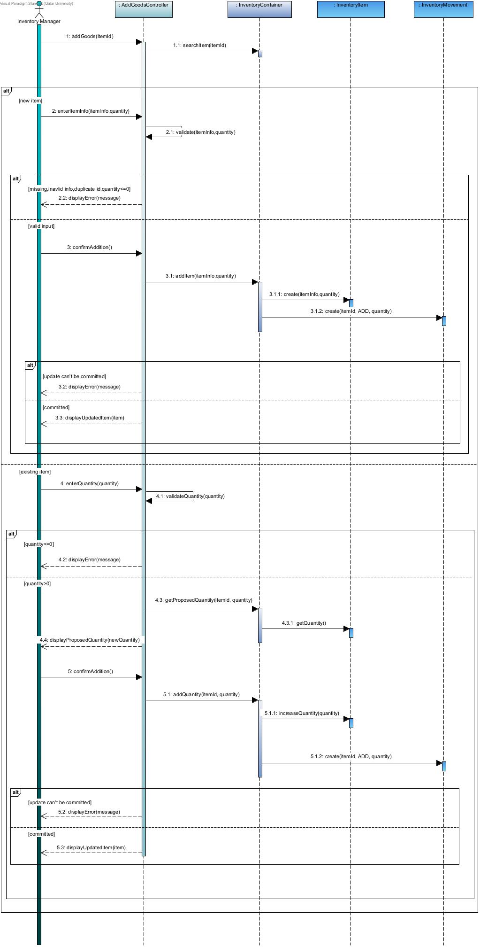

- sequence diagrams for UC13 – Process Sale:

- Focused class diagram:

- Explain any significant changes from milestone 1:

Task 2 – System Constraints and Non-Functional Requirements:
- Identification and classification of constraints:
- specification of three measurable NFRs:
- assumptions and scope distinction:

Task 3 – Java Implementation of the Selected Use Cases:
- Implementation of UC04:
- implementation of UC13 and supporting behaviors:
- validation and transaction consistency:
- JavaFX interface and demonstration:

Task 4 – Software Testing (choose 1 only):

Task 5 – Application of Two Software Design Patterns:
- First pattern – justification:
- UML design:
- Implementation:
- second pattern-justification:
- UML design:
- Implementation:

GitHub Repository URL:
https://github.com/shimaa-sm2212290/team-B52-G4

